IAN MOYES
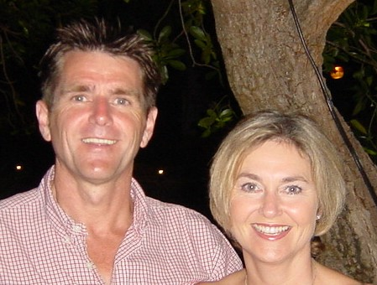
November 30th, 1955 - December 28th, 2003

To Ian:
Darling, my darling, one line in haste to tell you that I love you more today than ever in my life before, that I never see beauty without thinking of you or scent happiness without thinking of you. You have fulfilled all my ambition, realised all my hopes, made all my dreams come true.
You have set a crown of roses on my youth and fortified me against the disaster of our days.

Duff Cooper

Donations to the British Heart Foundation
and Isabel Hospice

Music:
Luther Vandross - Dance with my father
The Calling – Wherever you will go

The Parish Church of St. John the Evangelist, Digswell
11:00 Friday January 9th, 2004

IAN MOYES

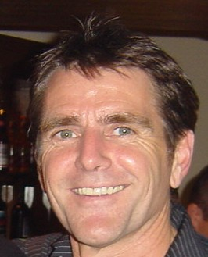

November 30th, 1955 - December 28th, 2003

Service conducted by Canon Carl Garner

Sermon conducted by Reverend Keith Moyes

ORDER OF SERVICE:

The Sentences, Welcome and Opening Prayer:
Canon Carl Garner

1st Hymn:
There is a green hill far away

Tributes:
Marco Pisani (Brother-in-Law)
Tony Irving (Friend)
Rudi Lamprecht (Siemens Managing Board Member)

1st Bible Reading:
1 Corinthians 15, Verse 19 FF

2nd Hymn:
The Lord’s my shepherd, I’ll not want

The Gospel:
John 14, 1-6, 27

The Sermon:
Reverend Keith Moyes

Prayers

3rd Hymn:
Lord of all Hopefulness

Commendation

There is a green hill far away
There is a green hill far away,
outside a city wall,
where our dear Lord was crucified
who died to save us all.
We may not know, we cannot tell,
what pains he had to bear,
but we believe it was for us
he hung and suffered there.
He died that we might be forgiven,
he died to make us good,
that we might go at last to heaven,
saved by his precious blood.
O dearly, dearly has he loved!
And we must love him too,
and trust in his redeeming blood,
and try his works to do.

The Lord’s my shepherd, I’ll not want
The Lord's my Shepherd, I'll not want.
he makes me down to lie
in pastures green; he leadeth me
the quiet waters by.
My soul he doth restore again;
and me to walk doth make
within the paths of righteousness,
even for his own Name's sake.
Yea, though I walk in death's dark vale,
yet will I fear no ill;
for thou art with me; and thy rod
and staff my comfort still.

My table thou hast furnished
in presence of my foes;
my head thou dost with oil anoint,
and my cup overflows.
Goodness and mercy all my life
shall surely follow me;
and in God's house for evermore
my dwelling place shall be.

Lord of all Hopefulness
Lord of all hopefulness, Lord of all joy,
Whose trust, ever child-like, no cares could destroy,
Be there at our waking, and give us, we pray,
Your bliss in our hearts, Lord, at the break of the day.
Lord of all eagerness, Lord of all faith,
Whose strong hands were skilled at the plane and the lathe,
Be there at our labours, and give us, we pray,
Your strength in our hearts, Lord, at the noon of the day.
Lord of all kindliness, Lord of all grace,
Your hands swift to welcome, your arms to embrace,
Be there at our homing, and give us, we pray,
Your love in our hearts, Lord, at the eve of the day.
Lord of all gentleness, Lord of all calm,
Whose voice is contentment, whose presence is balm,
Be there at our sleeping, and give us, we pray,
Your peace in our hearts, Lord, at the end of the day.

